1.4 Assessed Homework Mark Scheme

1. (a) (i) 1s2 2s2 2p6 3s2 3p1 (1)
Allow subscripted electron numbers
(ii) p (block) (1) 2
Allow upper or lower case ‘s’ and ‘p’ in (a)(i) and (a)(ii)
(b) Lattice of metal / +ve ions/ cations / atoms (1)
Not +ve nuclei/centres
Accept regular array/close packed/tightly packed/uniformly arranged
(Surrounded by) delocalised electrons (1) 2
Note: Description as a ‘giant ionic lattice’ = CE
(c) Greater nuclear or ionic charge or more protons (1)
Smaller atoms / ions (1)
Accept greater charge density for either M1 or M2
More delocalised electrons / e– in sea of e– / free e– (1)
Stronger attraction between ions and delocalised / free electrons etc. (1) 3
Max 3
Note: ‘intermolecular attraction/ forces’ or covalent molecules = CE
Accept stronger ‘electrostatic attraction’ if phrase prescribed elsewhere
Ignore references to m/z values
If Mg or Na compared to Al, rather than to each other, then: Max 2
Treat description that is effectively one for Ionisation Energy as a ‘contradiction’
(d) (Delocalised) electrons (1)
Move / flow in a given direction (idea of moving non-randomly)
or under the influence applied pd QoL mark (1) 2
Allow ‘flow through metal’
Not: ‘Carry the charge’; ‘along the layers’; ‘move through the metal’
[9]
2. (a) Enthalpy change/required when an electron is removed/knocked 1
out/displaced (Ignore ‘minimum’ energy)
From a gaseous atom 1
(could get this mark from equation)
(b) Mg+(g)  Mg2+(g) + e– Equation 1
Or Mg+(g) + e–  Mg2+(g) + 2e– State symbols (Tied to M1) 1
(c) Increased/stronger nuclear charge or more protons 1
Smaller atom or electrons enter the same shell or same/similar shielding 1
(d) Electron removed from a shell of lower energy or smaller atom or e– nearer 1
nucleus or e– removed from 2p rather than from 3s
Less shielding 1
(Do not accept ‘e– from inner shell’)
[8]

3. (a) 3

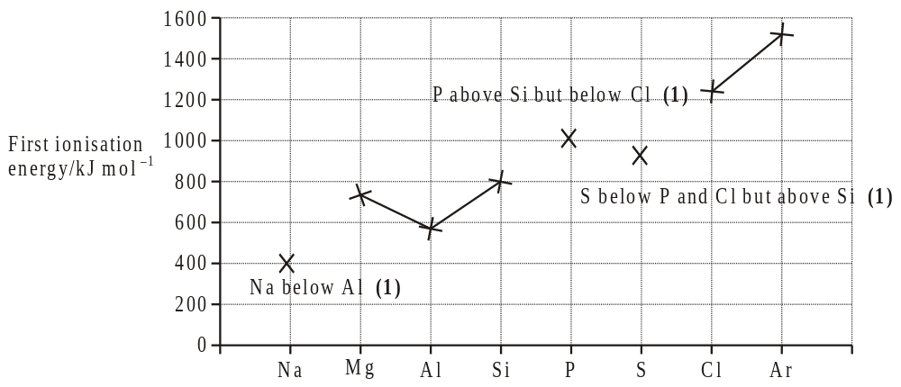

(b) Increased nuclear charge / proton number (1)
NOT increased atomic number
Electrons enter same shell / energy level OR atoms get smaller
OR same shielding (1)
Stronger attraction between nucleus and (outer) electrons (1) 3
Q of L
(c) Explanation for aluminium: (third) electron in (3)p sub-shell (1)
Sub-shell further away from nucleus OR of higher energy (1)
OR extra shielding from (3)s
Explanation for sulphur: Pair of electrons in (3)p orbital (1)
Repulsion between electrons (1) 4
tied to reference to e– pair in M3
Penalise ‘2p’ once only
[10]

4. (a) power of an atom to attract electrons (1)
in a covalent bond (1) 2
(b) number of protons increases (1)
electrons in same shell (or similar shielding) (1) 2
(c) Electronegativity of chlorine allow 2.8 – 3.0 (1)
Electronegativity of lithium allow 0.91 –1.5 2
(d) Trend decreases (1)
Explanation outer electrons further from nucleus (1)
more shielding from the nucleus (1)
(or more shells or increasing radius) 3
[9]

